Chapter 16, Problem 32.

For the network in Fig. 16.55, solve for i(t) for t > 0.

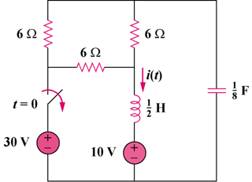

Figure 16.55
For Prob. 16.32.

